**How to Install Anaconda2 - 4.1.1**

1. Run the setup file of Anaconda2- 4.1.1.Click on the “Next” button.

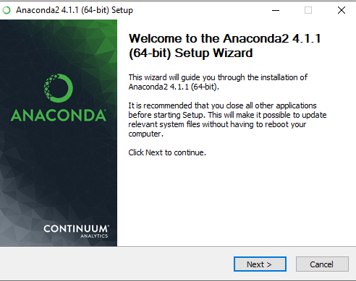

1. Read the “License Agreement “carefully and click the “I Agree” button.

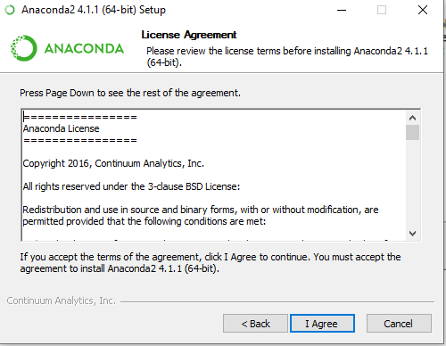

1. Select Installation Type according to the user requirement. In my Case I install “all users” and Click on the “Next” Button.

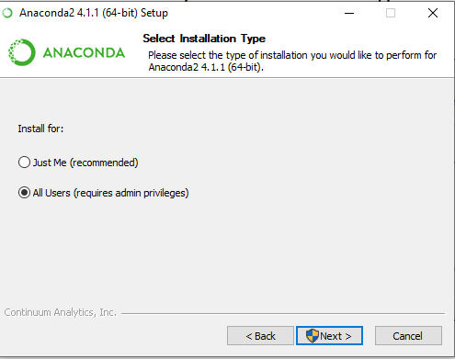

1. Choose the Installation Location and click on the “Next” Button.

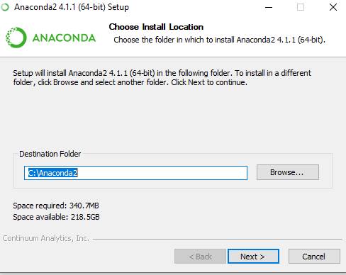

1. Select the “Advance Installation Options” and check mark both “Add Anaconda to the system PATH Environmental Variable” option and “Register Anaconda as the System Python 2.7”.

Click on “Install” Button.

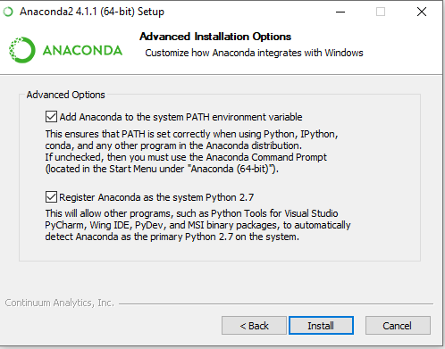

1. Wait a few minute Installation will be complete and click on the “Next” button.

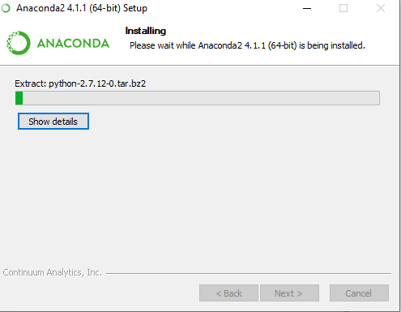

1. Installation process has been completed. Click on the “Next” Button.

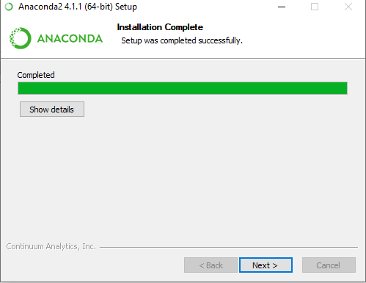

1. Anaconda2- 4.1.1 software Successfully Installed and Click on “Finish” Button.

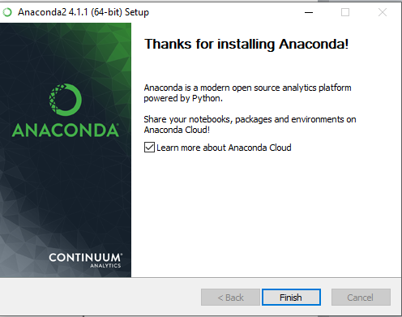

1. Preview of Software as below.

